**Data Testing Assessment**

A school 'Study & Play' has different branches in India. Students appeared in 10th & 12th board have scored good marks in different subjects. 'Study & Play' wants to recognize teachers across different streams to award them for their student's performance.

'Student & Play' are looking for a data warehouse solution to do analysis on student performance in a particular branch or subject.

**Exercise -**

As a part of this exercise, use the below Student data to import in database table.

Sample Data –

|  |  |  |  |  |
| --- | --- | --- | --- | --- |
| Student Name | StudentRollNo | Class | Age | Father's Name |
| AJAY KUMAR | IETLINF01 | X | 16 | PREM KUMAR |
| RAJAT MISHRA | IETLINF02 | XI | 17 | PANKAJ MISHRA |
| SUDHEER SHARMA | IETLINF03 | IX | 15 | SUNDER SHARMA |
| NANCY KAUR | IETLINF04 | XII | 18 | AK SINGH |
| SUMITA SHARMA | IETLINF05 | IV | 14 | AJAY SHARMA |
| NANDINI GUPTA | IETLINF06 | VII | 18 | RAM GUPTA |
| RAM KUMAR | IETLINF07 | X | 16 | RAMAN KUMAR |

Tasks

1. Create above table in database and insert the data.
2. Write sql query to find out total number of students in each class.
3. Write sql query to find out average age of students in each class.
4. Write sql query to find out the number of students having same roll no.
5. Write sql query to view the duplicate name of a student from the table.
6. **Create above table in database and insert the data.**

🡪***To create table***

Create table StudentDetail

(StudentName varchar2(100) not null , StudentRollNo varchar2(150) primary key,

class varchar2(50), Age number,

Fathers_Name varchar2(100));

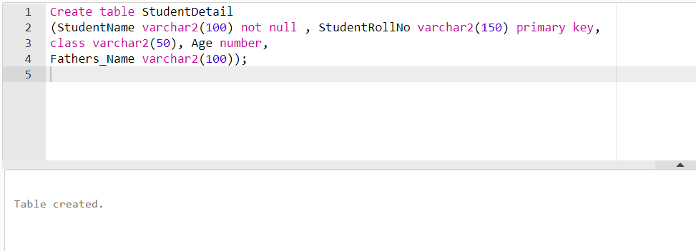

🡪***To insert the data.***

Insert into StudentDetail values ('AJAY KUMAR','IETLINF01','X',16,'PREM KUMAR');

Insert into StudentDetail values ('RAJAT MISHRA','IETLINF02','XI',17,'PANKAJ MISHRA');

Insert into StudentDetail values ('SUDHEER SHARMA','IETLINF03','IX',15,'SUNDER SHARMA');

Insert into StudentDetail values ('NANCY KAUR','IETLINF04','XII',18,'AK SINGH');

Insert into StudentDetail values ('SUMITA SHARMA','IETLINF05','IV',14,'AJAY SHARMA');

Insert into StudentDetail values ('NANDINI GUPTA','IETLINF06','VII',18,'RAM GUPTA');

Insert into StudentDetail values ('RAM KUMAR','IETLINF07','X',16,'RAMAN KUMAR');

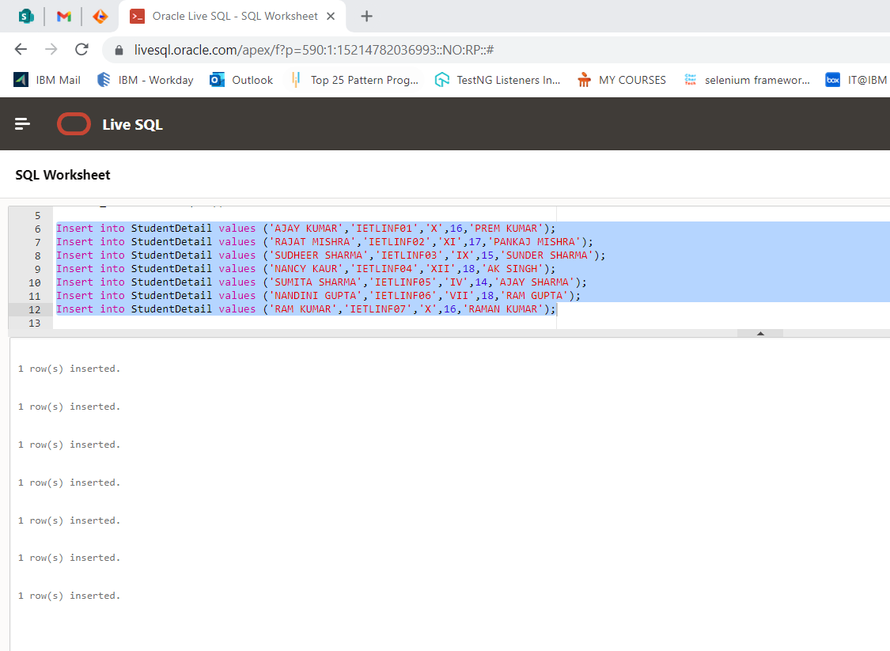

1. **Write sql query to find out total number of students in each class.**

SELECT class,count( * ) AS total_number_of_students FROM StudentDetail GROUP BY class

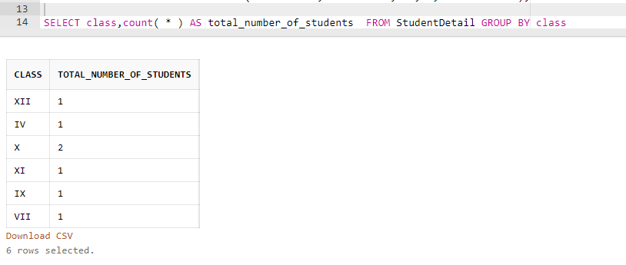

1. **Write sql query to find out average age of students in each class.**select class,avg(Age) AS Average_age FROM StudentDetail GROUP BY class

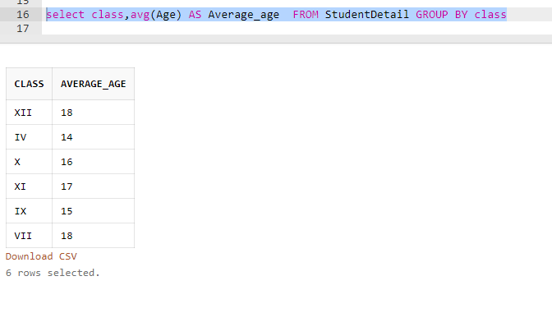

1. **Write sql query to find out the number of students having same roll no.**

SELECT StudentRollNo,count(StudentRollNo)AS SameRollNumber FROM StudentDetail GROUP BY StudentRollNo HAVING cOUNT(StudentRollNo)>1

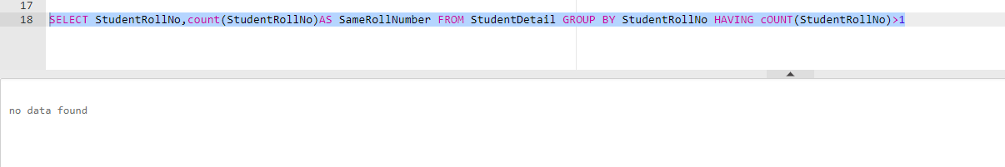

1. **Write sql query to view the duplicate name of a student from the table.**

SELECT StudentName,count(StudentName)AS DuplicateName FROM StudentDetail GROUP BY StudentName HAVING cOUNT(StudentName)>1

